**Web Application**

**1) Create Extranet Web Application**

In Central Admin > Application Management > Manage web applications > New (on ribbon)

Pick & edit values as needed.

Uncheck “Enable Windows Authentication” Check “**Enable Forms Based Authentication**”

Enter role and membership provider as below:

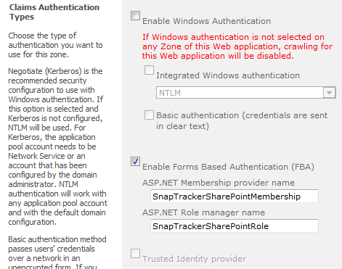

**2) Allow access to open all types of file in SharePoint**

- Central Administration > [Application Management](http://evadne7:17076/applications.aspx) > [Manage web applications](http://evadne7:17076/_admin/WebApplicationList.aspx)

- highlight web app and click General Settings (on ribbon)

- select permissive under Browser File Handling then hit ok

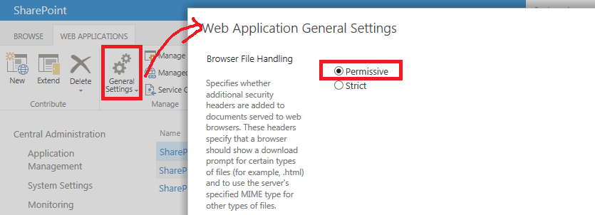

**3) Change managed path**

- Central Administration > [Application Management](http://evadne7:17076/applications.aspx) > [Manage web applications](http://evadne7:17076/_admin/WebApplicationList.aspx)

- highlight web app and click Managed Paths (on ribbon)

- delete all paths

- add root (/) as wildcard inclusion path

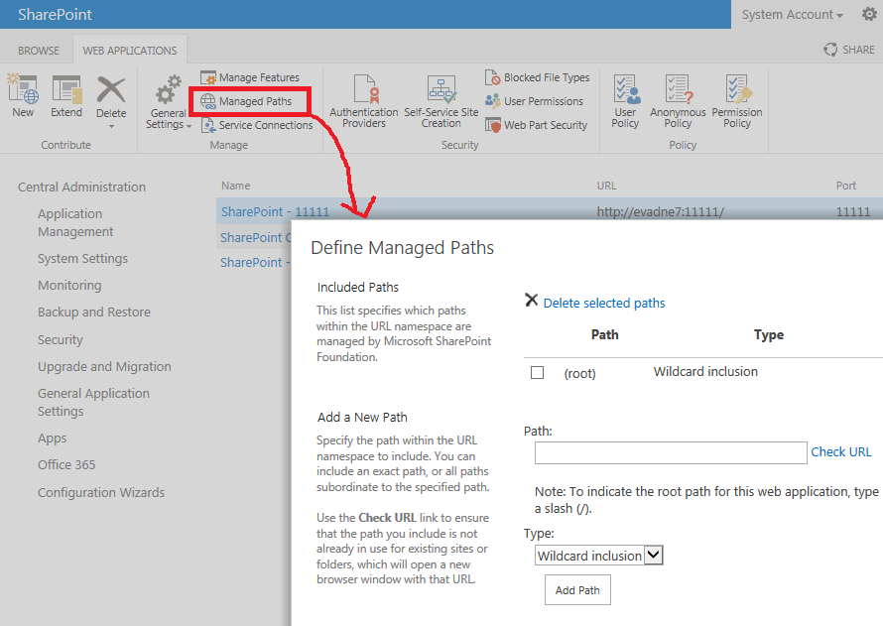

**Site Collection**

**1) Create a separate database**

- Central Administration > [Application Management](http://evadne7:17076/applications.aspx) > Databases > Manage content databases

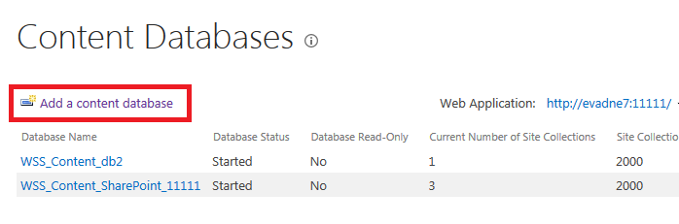

- fill in all the needed fields; usually just fill in new db name

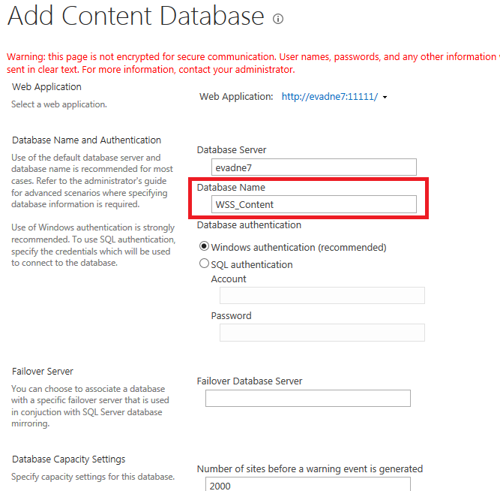

- hit ok. After it is done any new site collection created will be in this database, which means if we want to separate all site collection we need to create a db before each site collection creation.

**2) Create a site collection**

- Central Administration > [Application Management](http://evadne7:17076/applications.aspx) > Create site collections

- select your web application + enter a title + description

- select URL to “/” + enter dealer name

- select team site template

- enter system as admin

- click ok

